Multi-Area OSPF

# CCNP Lab 1

## Axel Li

## 6 September 2018

# Purpose

The purpose of the lab was to review OSPF and OSPFv3, important concepts learned in a previous CCNA course. The task to implement multi-area OSPF with IPv4 and IPv6 in a simple network of three switches, three routers, and two hosts within a backbone area and three other areas. Within the network, hosts should be able to communicate across areas and ping each other.

# Background

OSPF (Open Shortest Path First) and OSPFv3 are link-state routing protocols for IPv4 (Internet Protocol) and IPv6 networks, respectively. Within OSPF, routers and layer 3 switches are able to exchange regular updates regarding the status of their neighbors, which are echoed through the network. This constant updating enables each device to build its own network topology and keep it up to date. Similar to a GPS that automatically determines and updates the best path of travel, OPSF allows the devices to determine optimal routes to remote destinations and adjust to network changes (such as a device failure) without manual configuration.

Multi-area OSPF builds on OSPF, utilizing an additional concept called “areas”, which are essentially groups of network devices. Having multiple areas assists in reducing network load from large numbers of routing updates and large topological databases, and allows network administrators to organize the network into groups as desired. Similar to how in classroom discussions students may talk among table groups first and delegate a representative to speak for the group, updates are limited to within each area and summaries are sent between areas instead of sending routing information between every single device. As dictated by multi-area OSPF, all areas must neighbor the backbone area, or area 0.

# Summary

Before physically configuring the devices, my partner and I planned out the topology, addressing and port scheme, and areas. As the devices were similar in configuration, we then created a generic configuration that we could copy multiple times and modify slightly for each individual device. In the configuration itself, we enabled ipv6 routing and disabled switching (on the layer 3 switches), set IP addresses, input network commands, and set router-IDs on the devices.

After creating the configurations, we connected the cables between the devices and pasted the configurations we prepared into each device. To test the devices, we then input various show and ping commands to confirm that the network was set up and working as intended.

# Commands

The key commands used in this lab were:

sdm prefer dual-ipv4-and-ipv6 default – configures layer 3 switches to support both IPv4 and IPv6 traffic upon reload

no switchport – disables layer 2 switching and enables layer 3 routing on an interface on layer 3 switches

ip routing – enables routing on layer 3 switches

router ospf [process-id] – creates an OSPF routing process and enters router configuration mode

router ospfv3 [process-id] – creates an OSPFv3 routing process and enters router configuration mode

router-id [router-id] – configures the router-id of the device

network [network-address] [wildcard-mask] area [area-id] – enables OSPF for the IPv4 network and assigns it to the specified area

ipv6 ospf [process-id] area [area-id]– enables OSPFv3 for the IPv6 network and assigns it to the specified area

passive-interface [interface] – configures an interface as passive and prevents routing updates from being sent out through the specified interface

show run – outputs the full configuration of the device

show ip route – displays all known IPv4 routes stored in the routing table

show ipv6 route – displays all known IPv6 routes stored in the routing table

show ip ospf neighbors – displays the information of all OSPF neighbors of the device

show ipv6 ospf neighbors – displays the information of all OSPFv3 neighbors of the device

# Diagrams

Table of Devices, Ports, Addresses, and Areas:

|  |  |  |  |  |  |
| --- | --- | --- | --- | --- | --- |
| **Device** | **Port** | **IPv4 Address** | **Subnet Mask** | **IPv6 Address** | **Area** |
| Switch 1 | f1/0/1 | 172.16.12.1 | 255.255.255.252 | 2001:db8:acad:12::1/64 | 0 |
| f1/0/24 | 172.16.1.1 | 255.255.255.252 | 2001:db8:acad:1::1/64 | 1 |
| Switch 2 | f1/0/1 | 172.16.12.2 | 255.255.255.252 | 2001:db8:acad:12::2/64 | 0 |
| f1/0/2 | 172.16.23.1 | 255.255.255.252 | 2001:db8:acad:23::1/64 | 0 |
| f1/0/24 | 172.16.2.1 | 255.255.255.252 | 2001:db8:acad:2::1/64 | 2 |
| Switch 3 | f1/0/2 | 172.16.23.2 | 255.255.255.252 | 2001:db8:acad:23::2/64 | 0 |
| f1/0/24 | 172.16.3.1 | 255.255.255.252 | 2001:db8:acad:3::1/64 | 3 |
| Router 1 | g0/0 | 172.16.1.2 | 255.255.255.252 | 2001:db8:acad:1::2/64 | 1 |
| g0/1 | 192.168.1.1 | 255.255.255.0 | 2001:db8:acad:a::1/64 | 1 |
| Router 2 | g0/0 | 172.16.2.2 | 255.255.255.252 | 2001:db8:acad:2::2/64 | 2 |
| g0/1 | 192.168.2.1 | 255.255.255.0 | 2001:db8:acad:b::1/64 | 2 |
| Router 3 | g0/0 | 172.16.3.2 | 255.255.255.252 | 2001:db8:acad:3::2/64 | 3 |
| g0/1 | 192.168.3.1 | 255.255.255.0 | 2001:db8:acad:c::1/64 | 3 |
| Host 1 | N/A | 192.168.1.10 | 255.255.255.0 | 2001:db8:acad:a::10/64 | N/A |
| Host 2 | N/A | 192.168.2.10 | 255.255.255.0 | 2001:db8:acad:b::10/64 | N/A |
| Host 3 | N/A | 192.168.3.10 | 255.255.255.0 | 2001:db8:acad:c::10/64 | N/A |

Network Topology with Ports:

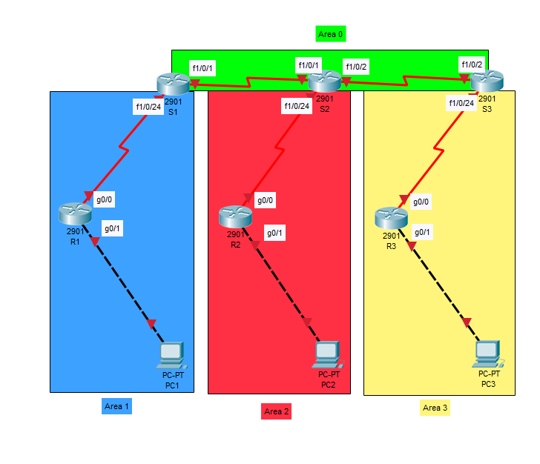

Network Topology with IPv4 Addresses:

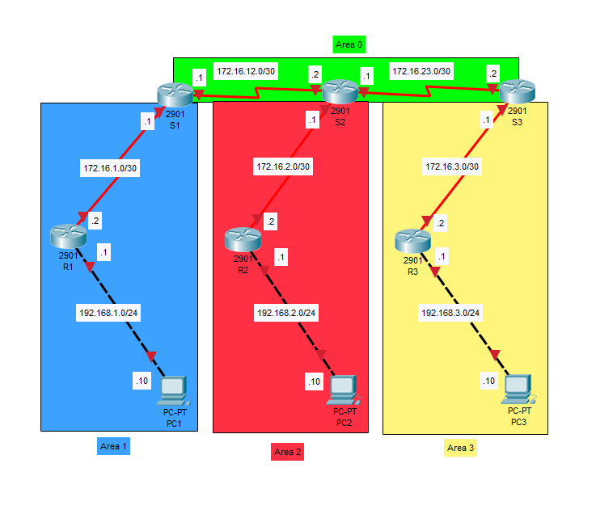

Network Topology with IPv6 Addresses:

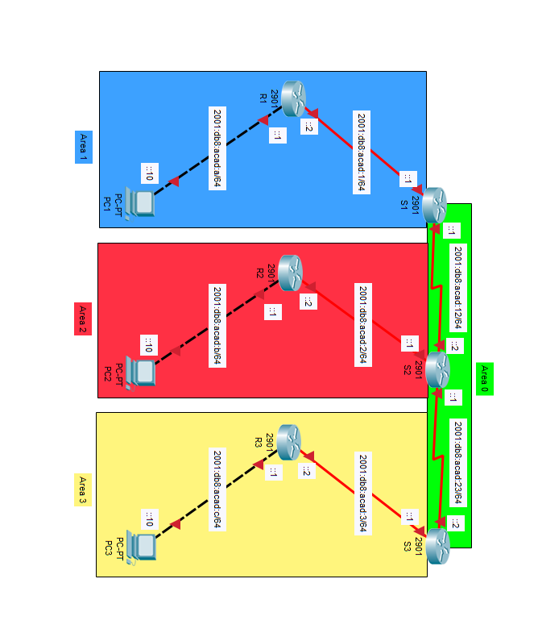

# Configurations

* Note that some information irrelevant to the lab may be excluded in the outputs pasted below. *

**S1 Configuration:**

**S1#**show run

Current configuration : 4162 bytes

Last configuration change at 00:19:31 UTC Mon Mar 1 1993

version 12.2

no service pad

service timestamps debug uptime

service timestamps log uptime

no service password-encryption

hostname S1

ip routing

ipv6 unicast-routing

interface FastEthernet1/0/1

no switchport

ip address 172.16.12.1 255.255.255.252

ipv6 address 2001:DB8:ACAD:12::1/64

ipv6 ospf 1 area 0

interface FastEthernet1/0/24

no switchport

ip address 172.16.1.1 255.255.255.252

ipv6 address 2001:DB8:ACAD:1::1/64

ipv6 ospf 1 area 1

router ospf 1

network 172.16.1.0 0.0.0.3 area 1

network 172.16.12.0 0.0.0.3 area 0

ipv6 router ospf 1

router-id 1.1.1.1

line con 0

line vty 0 4

login

line vty 5 15

login

end

**S1#**show ip route

Gateway of last resort is not set

     172.16.0.0/16 is variably subnetted, 7 subnets, 2 masks

C        172.16.1.0/30 is directly connected, FastEthernet1/0/24

L        172.16.1.1/32 is directly connected, FastEthernet1/0/24

O IA     172.16.2.0/30 [110/2] via 172.16.12.2, 00:40:03, FastEthernet1/0/1

O IA     172.16.3.0/30 [110/3] via 172.16.12.2, 00:40:03, FastEthernet1/0/1

C        172.16.12.0/30 is directly connected, FastEthernet1/0/1

L        172.16.12.1/32 is directly connected, FastEthernet1/0/1

O        172.16.23.0/30 [110/2] via 172.16.12.2, 00:40:13, FastEthernet1/0/1

O     192.168.1.0/24 [110/2] via 172.16.1.2, 00:39:27, FastEthernet1/0/24

O IA  192.168.3.0/24 [110/4] via 172.16.12.2, 00:31:04, FastEthernet1/0/1

**S1#**show ipv6 route

C   2001:DB8:ACAD:1::/64 [0/0]

    via FastEthernet1/0/24, directly connected

L   2001:DB8:ACAD:1::1/128 [0/0]

    via FastEthernet1/0/24, receive

OI  2001:DB8:ACAD:2::/64 [110/2]

    via FE80::225:B4FF:FE05:5C1, FastEthernet1/0/1

OI  2001:DB8:ACAD:3::/64 [110/3]

    via FE80::225:B4FF:FE05:5C1, FastEthernet1/0/1

O   2001:DB8:ACAD:A::/64 [110/2]

    via FE80::32E4:DBFF:FE67:1778, FastEthernet1/0/24

OI  2001:DB8:ACAD:C::/64 [110/4]

    via FE80::225:B4FF:FE05:5C1, FastEthernet1/0/1

C   2001:DB8:ACAD:12::/64 [0/0]

    via FastEthernet1/0/1, directly connected

L   2001:DB8:ACAD:12::1/128 [0/0]

    via FastEthernet1/0/1, receive

O   2001:DB8:ACAD:23::/64 [110/2]

    via FE80::225:B4FF:FE05:5C1, FastEthernet1/0/1

**S2 Configuration:**

**S2#**show run

Current configuration : 2596 bytes

Last configuration change at 00:24:09 UTC Mon Mar 1 1993

version 12.2

no service pad

service timestamps debug datetime msec

service timestamps log datetime msec

no service password-encryption

hostname S2

ip routing

ipv6 unicast-routing

interface FastEthernet1/0/1

no switchport

ip address 172.16.12.2 255.255.255.252

ipv6 address 2001:DB8:ACAD:12::2/64

ipv6 ospf 1 area 0

interface FastEthernet1/0/2

no switchport

ip address 172.16.23.1 255.255.255.252

ipv6 address 2001:DB8:ACAD:23::1/64

ipv6 ospf 1 area 0

interface FastEthernet1/0/24

no switchport

ip address 172.16.2.1 255.255.255.252

ipv6 address 2001:DB8:ACAD:2::1/64

ipv6 ospf 1 area 2

router ospf 1

network 172.16.2.0 0.0.0.3 area 2

network 172.16.12.0 0.0.0.3 area 0

network 172.16.23.0 0.0.0.3 area 0

ipv6 router ospf 1

router-id 2.2.2.2

line con 0

line vty 5 15

end

**S2#**show ip route

Gateway of last resort is not set

     172.16.0.0/16 is variably subnetted, 8 subnets, 2 masks

O IA     172.16.1.0/30 [110/2] via 172.16.12.1, 00:48:17, FastEthernet1/0/1

C        172.16.2.0/30 is directly connected, FastEthernet1/0/24

L        172.16.2.1/32 is directly connected, FastEthernet1/0/24

O IA     172.16.3.0/30 [110/2] via 172.16.23.2, 00:48:17, FastEthernet1/0/2

C        172.16.12.0/30 is directly connected, FastEthernet1/0/1

L        172.16.12.2/32 is directly connected, FastEthernet1/0/1

C        172.16.23.0/30 is directly connected, FastEthernet1/0/2

L        172.16.23.1/32 is directly connected, FastEthernet1/0/2

O IA  192.168.1.0/24 [110/3] via 172.16.12.1, 00:47:41, FastEthernet1/0/1

O IA  192.168.3.0/24 [110/3] via 172.16.23.2, 00:39:18, FastEthernet1/0/2

**S2#**show ipv6 route

OI  2001:DB8:ACAD:1::/64 [110/2]

    via FE80::5ABC:27FF:FE6C:81C1, FastEthernet1/0/1

C   2001:DB8:ACAD:2::/64 [0/0]

    via FastEthernet1/0/24, directly connected

L   2001:DB8:ACAD:2::1/128 [0/0]

    via FastEthernet1/0/24, receive

OI  2001:DB8:ACAD:3::/64 [110/2]

    via FE80::128C:CFFF:FE1F:EDC1, FastEthernet1/0/2

OI  2001:DB8:ACAD:A::/64 [110/3]

    via FE80::5ABC:27FF:FE6C:81C1, FastEthernet1/0/1

OI  2001:DB8:ACAD:C::/64 [110/3]

    via FE80::128C:CFFF:FE1F:EDC1, FastEthernet1/0/2

C   2001:DB8:ACAD:12::/64 [0/0]

    via FastEthernet1/0/1, directly connected

L   2001:DB8:ACAD:12::2/128 [0/0]

    via FastEthernet1/0/1, receive

C   2001:DB8:ACAD:23::/64 [0/0]

    via FastEthernet1/0/2, directly connected

L   2001:DB8:ACAD:23::1/128 [0/0]

    via FastEthernet1/0/2, receive

L   FF00::/8 [0/0]

    via Null0, receive

**S3 Configuration:**

**S3#**show run

Current configuration : 2513 bytes

Last configuration change at 00:31:50 UTC Mon Mar 1 1993

version 12.2

no service pad

service timestamps debug datetime msec

service timestamps log datetime msec

no service password-encryption

hostname S3

ip routing

ipv6 unicast-routing

interface FastEthernet1/0/2

no switchport

ip address 172.16.23.2 255.255.255.252

ipv6 address 2001:DB8:ACAD:23::2/64

ipv6 ospf 1 area 0

interface FastEthernet1/0/24

no switchport

ip address 172.16.3.1 255.255.255.252

ipv6 address 2001:DB8:ACAD:3::1/64

ipv6 ospf 1 area 3

router ospf 1

network 172.16.3.0 0.0.0.3 area 3

network 172.16.23.0 0.0.0.3 area 0

ipv6 router ospf 1

router-id 3.3.3.3

line con 0

line vty 5 15

end

**S3#**show ip route

Gateway of last resort is not set

     172.16.0.0/16 is variably subnetted, 7 subnets, 2 masks

O IA     172.16.1.0/30 [110/3] via 172.16.23.1, 00:52:42, FastEthernet1/0/2

O IA     172.16.2.0/30 [110/2] via 172.16.23.1, 00:52:43, FastEthernet1/0/2

C        172.16.3.0/30 is directly connected, FastEthernet1/0/24

L        172.16.3.1/32 is directly connected, FastEthernet1/0/24

O        172.16.12.0/30 [110/2] via 172.16.23.1, 00:52:48, FastEthernet1/0/2

C        172.16.23.0/30 is directly connected, FastEthernet1/0/2

L        172.16.23.2/32 is directly connected, FastEthernet1/0/2

O IA  192.168.1.0/24 [110/4] via 172.16.23.1, 00:52:06, FastEthernet1/0/2

O     192.168.3.0/24 [110/2] via 172.16.3.2, 00:43:44, FastEthernet1/0/24

**S3#**show ipv6 route

OI  2001:DB8:ACAD:1::/64 [110/3]

    via FE80::225:B4FF:FE05:5C3, FastEthernet1/0/2

OI  2001:DB8:ACAD:2::/64 [110/2]

    via FE80::225:B4FF:FE05:5C3, FastEthernet1/0/2

C   2001:DB8:ACAD:3::/64 [0/0]

    via FastEthernet1/0/24, directly connected

L   2001:DB8:ACAD:3::1/128 [0/0]

    via FastEthernet1/0/24, receive

OI  2001:DB8:ACAD:A::/64 [110/4]

    via FE80::225:B4FF:FE05:5C3, FastEthernet1/0/2

O   2001:DB8:ACAD:C::/64 [110/2]

    via FE80::26E9:B3FF:FE3C:1C60, FastEthernet1/0/24

O   2001:DB8:ACAD:12::/64 [110/2]

    via FE80::225:B4FF:FE05:5C3, FastEthernet1/0/2

C   2001:DB8:ACAD:23::/64 [0/0]

    via FastEthernet1/0/2, directly connected

L   2001:DB8:ACAD:23::2/128 [0/0]

    via FastEthernet1/0/2, receive

L   FF00::/8 [0/0]

    via Null0, receive

**R1 Configuration:**

**R1#**show run

Current configuration : 2080 bytes

Last configuration change at 18:46:50 UTC Wed Sep 5 2018

version 15.2

service timestamps debug datetime msec

service timestamps log datetime msec

no service password-encryption

hostname R1

ipv6 unicast-routing

interface GigabitEthernet0/0

ip address 172.16.1.2 255.255.255.252

ip broadcast-address 172.16.1.0

duplex auto

speed auto

ipv6 address 2001:DB8:ACAD:1::2/64

ipv6 ospf 1 area 1

interface GigabitEthernet0/1

ip address 192.168.1.1 255.255.255.0

ip broadcast-address 192.168.1.0

duplex auto

speed auto

ipv6 address 2001:DB8:ACAD:A::1/64

ipv6 ospf 1 area 1

router ospf 1

passive-interface GigabitEthernet0/1

network 172.16.1.0 0.0.0.3 area 1

network 192.168.1.0 0.0.0.255 area 1

ipv6 router ospf 1

router-id 10.10.10.10

passive-interface GigabitEthernet0/1

line con 0

line aux 0

line 2

no activation-character

no exec

transport preferred none

transport output lat pad telnet rlogin lapb-ta mop udptn v120 ssh

stopbits 1

line vty 0 4

login

transport input all

scheduler allocate 20000 1000

end

**R1#**show ip route

Gateway of last resort is not set

     172.16.0.0/16 is variably subnetted, 6 subnets, 2 masks

C        172.16.1.0/30 is directly connected, GigabitEthernet0/0

L        172.16.1.2/32 is directly connected, GigabitEthernet0/0

O IA     172.16.2.0/30 [110/3] via 172.16.1.1, 00:54:12, GigabitEthernet0/0

O IA     172.16.3.0/30 [110/4] via 172.16.1.1, 00:54:12, GigabitEthernet0/0

O IA     172.16.12.0/30 [110/2] via 172.16.1.1, 00:54:12, GigabitEthernet0/0

O IA     172.16.23.0/30 [110/3] via 172.16.1.1, 00:54:12, GigabitEthernet0/0

     192.168.1.0/24 is variably subnetted, 2 subnets, 2 masks

C        192.168.1.0/24 is directly connected, GigabitEthernet0/1

L        192.168.1.1/32 is directly connected, GigabitEthernet0/1

O IA  192.168.3.0/24 [110/5] via 172.16.1.1, 00:45:50, GigabitEthernet0/0

**R1#**show ipv6 route

C   2001:DB8:ACAD:1::/64 [0/0]

    via GigabitEthernet0/0, directly connected

L   2001:DB8:ACAD:1::2/128 [0/0]

    via GigabitEthernet0/0, receive

OI  2001:DB8:ACAD:2::/64 [110/3]

    via FE80::5ABC:27FF:FE6C:81C3, GigabitEthernet0/0

OI  2001:DB8:ACAD:3::/64 [110/4]

    via FE80::5ABC:27FF:FE6C:81C3, GigabitEthernet0/0

C   2001:DB8:ACAD:A::/64 [0/0]

    via GigabitEthernet0/1, directly connected

L   2001:DB8:ACAD:A::1/128 [0/0]

    via GigabitEthernet0/1, receive

OI  2001:DB8:ACAD:C::/64 [110/5]

    via FE80::5ABC:27FF:FE6C:81C3, GigabitEthernet0/0

OI  2001:DB8:ACAD:12::/64 [110/2]

    via FE80::5ABC:27FF:FE6C:81C3, GigabitEthernet0/0

OI  2001:DB8:ACAD:23::/64 [110/3]

    via FE80::5ABC:27FF:FE6C:81C3, GigabitEthernet0/0

L   FF00::/8 [0/0]

    via Null0, receive

**R2 Configuration:**

**R2#**show run

Current configuration : 1893 bytes

Last configuration change at 18:52:35 UTC Wed Sep 5 2018

version 15.2

service timestamps debug datetime msec

service timestamps log datetime msec

no service password-encryption

hostname R2

ipv6 unicast-routing

interface GigabitEthernet0/0

ip address 172.16.2.2 255.255.255.252

duplex auto

speed auto

ipv6 address 2001:DB8:ACAD:2::2/64

ipv6 ospf 1 area 2

interface GigabitEthernet0/1

ip address 192.168.2.1 255.255.255.0

duplex auto

speed auto

ipv6 address 2001:DB8:ACAD:B::1/64

ipv6 ospf 1 area 2

router ospf 1

passive-interface GigabitEthernet0/1

network 172.16.2.0 0.0.0.3 area 2

network 192.168.2.0 0.0.0.255 area 2

ipv6 router ospf 1

router-id 20.20.20.20

passive-interface GigabitEthernet0/1

line con 0

line aux 0

line 2

no activation-character

no exec

transport preferred none

transport output lat pad telnet rlogin lapb-ta mop udptn v120 ssh

stopbits 1

line vty 0 4

login

transport input all

scheduler allocate 20000 1000

end

**R2#**show ip route

Gateway of last resort is not set

     172.16.0.0/16 is variably subnetted, 6 subnets, 2 masks

O IA     172.16.1.0/30 [110/3] via 172.16.2.1, 00:47:11, GigabitEthernet0/0

C        172.16.2.0/30 is directly connected, GigabitEthernet0/0

L        172.16.2.2/32 is directly connected, GigabitEthernet0/0

O IA     172.16.3.0/30 [110/3] via 172.16.2.1, 00:47:11, GigabitEthernet0/0

O IA     172.16.12.0/30 [110/2] via 172.16.2.1, 00:47:11, GigabitEthernet0/0

O IA     172.16.23.0/30 [110/2] via 172.16.2.1, 00:47:11, GigabitEthernet0/0

O IA  192.168.1.0/24 [110/4] via 172.16.2.1, 00:47:11, GigabitEthernet0/0

O IA  192.168.3.0/24 [110/4] via 172.16.2.1, 00:46:48, GigabitEthernet0/0

**R2#**show ipv6 route

OI  2001:DB8:ACAD:1::/64 [110/3]

    via FE80::225:B4FF:FE05:5C4, GigabitEthernet0/0

C   2001:DB8:ACAD:2::/64 [0/0]

    via GigabitEthernet0/0, directly connected

L   2001:DB8:ACAD:2::2/128 [0/0]

    via GigabitEthernet0/0, receive

OI  2001:DB8:ACAD:3::/64 [110/3]

    via FE80::225:B4FF:FE05:5C4, GigabitEthernet0/0

OI  2001:DB8:ACAD:A::/64 [110/4]

    via FE80::225:B4FF:FE05:5C4, GigabitEthernet0/0

OI  2001:DB8:ACAD:C::/64 [110/4]

    via FE80::225:B4FF:FE05:5C4, GigabitEthernet0/0

OI  2001:DB8:ACAD:12::/64 [110/2]

    via FE80::225:B4FF:FE05:5C4, GigabitEthernet0/0

OI  2001:DB8:ACAD:23::/64 [110/2]

    via FE80::225:B4FF:FE05:5C4, GigabitEthernet0/0

L   FF00::/8 [0/0]

    via Null0, receive

**R3 Configuration:**

**R3#**show run

Current configuration : 1883 bytes

Last configuration change at 18:37:10 UTC Wed Sep 5 2018

version 15.2

service timestamps debug datetime msec

service timestamps log datetime msec

no service password-encryption

hostname R3

ipv6 unicast-routing

interface GigabitEthernet0/0

ip address 172.16.3.2 255.255.255.252

duplex auto

speed auto

ipv6 address 2001:DB8:ACAD:3::2/64

ipv6 ospf 1 area 3

interface GigabitEthernet0/1

ip address 192.168.3.1 255.255.255.0

duplex auto

speed auto

ipv6 address 2001:DB8:ACAD:C::1/64

ipv6 ospf 1 area 3

router ospf 1

passive-interface GigabitEthernet0/1

network 172.16.1.0 0.0.0.3 area 3

network 172.16.3.0 0.0.0.3 area 3

network 192.168.1.0 0.0.0.255 area 3

network 192.168.3.0 0.0.0.255 area 3

ipv6 router ospf 1

router-id 30.30.30.30

passive-interface GigabitEthernet0/1

line con 0

line aux 0

line 2

no activation-character

no exec

transport preferred none

transport output lat pad telnet rlogin lapb-ta mop udptn v120 ssh

stopbits 1

line vty 0 4

login

transport input all

scheduler allocate 20000 1000

end

**R3#**show ip route

Gateway of last resort is not set

     172.16.0.0/16 is variably subnetted, 6 subnets, 2 masks

O IA     172.16.1.0/30 [110/4] via 172.16.3.1, 00:47:51, GigabitEthernet0/0

O IA     172.16.2.0/30 [110/3] via 172.16.3.1, 00:47:51, GigabitEthernet0/0

C        172.16.3.0/30 is directly connected, GigabitEthernet0/0

L        172.16.3.2/32 is directly connected, GigabitEthernet0/0

O IA     172.16.12.0/30 [110/3] via 172.16.3.1, 00:47:51, GigabitEthernet0/0

O IA     172.16.23.0/30 [110/2] via 172.16.3.1, 00:47:51, GigabitEthernet0/0

O IA  192.168.1.0/24 [110/5] via 172.16.3.1, 00:47:51, GigabitEthernet0/0

     192.168.3.0/24 is variably subnetted, 2 subnets, 2 masks

C        192.168.3.0/24 is directly connected, GigabitEthernet0/1

L        192.168.3.1/32 is directly connected, GigabitEthernet0/1

**R3#**show ipv6 route

OI  2001:DB8:ACAD:1::/64 [110/4]

    via FE80::128C:CFFF:FE1F:EDC3, GigabitEthernet0/0

OI  2001:DB8:ACAD:2::/64 [110/3]

    via FE80::128C:CFFF:FE1F:EDC3, GigabitEthernet0/0

C   2001:DB8:ACAD:3::/64 [0/0]

    via GigabitEthernet0/0, directly connected

L   2001:DB8:ACAD:3::2/128 [0/0]

    via GigabitEthernet0/0, receive

OI  2001:DB8:ACAD:A::/64 [110/5]

    via FE80::128C:CFFF:FE1F:EDC3, GigabitEthernet0/0

C   2001:DB8:ACAD:C::/64 [0/0]

    via GigabitEthernet0/1, directly connected

L   2001:DB8:ACAD:C::1/128 [0/0]

    via GigabitEthernet0/1, receive

OI  2001:DB8:ACAD:12::/64 [110/3]

    via FE80::128C:CFFF:FE1F:EDC3, GigabitEthernet0/0

OI  2001:DB8:ACAD:23::/64 [110/2]

    via FE80::128C:CFFF:FE1F:EDC3, GigabitEthernet0/0

L   FF00::/8 [0/0]

    via Null0, receive

# Problems

While working through the lab, we encountered a variety of problems within the configuration. For example, due to not working with layer 3 switches recently, we initially did not realize that we needed to disable switching on interfaces and enable both IPv4 and IPv6 simultaneously. After researching the properties of layer 3 switches online, we quickly realized that we had missed certain critical commands, such as no switchport and sdm prefer dual-ipv4-and-ipv6 default.

As the configurations between devices were extremely similar, we copied and pasted device-specific variations of a common configuration into another document; however this led to a copy-paste error in the network addresses. This problem was particularly challenging and tedious to solve, especially since we falsely assumed that the configured network addresses were all correct. After finding nothing wrong with the other parts of the configuration, we checked the addresses and realized that some were not correct in the first place. We eventually resolved the problem through careful scrutiny through each configuration to fix the typos and reconfigure the devices afterward.

Personally from this lab I have learned to never outright assume that some particular thing is done correctly (especially if it was not personally typed out), and with the lab I’ve also been able to gain further experience with layer 3 switches.

# Conclusion

Overall the lab was a simple exercise in configuring multi-area OSPF and OSPFv3 in a small network, which went relatively smoothly. Though there were some bumps along the way, especially with the addressing errors mentioned above, the lab was not particularly difficult or time consuming as it was serving as a review of concepts from the previous year. In completing the lab I’ve been able to review layer 3 switches and have learned to avoid making assumptions.